Entire function

Alias

Entire function

Integral function

Intro

It is a complex-valued function that is holomorphic on the whole complex plane.

Property

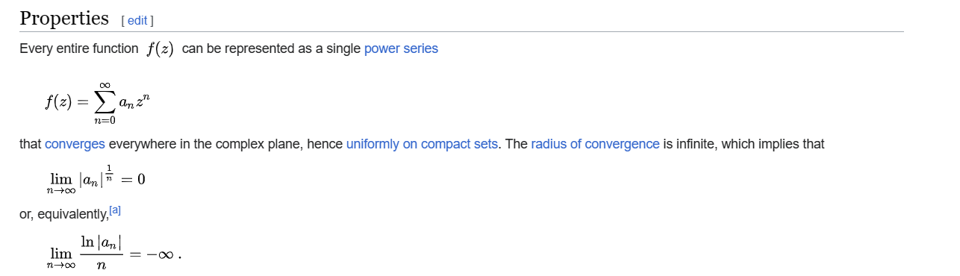

$$f\left(z\right)$$ = $$sigma\left(a_{n}z^{n},n=0,n=\inf{}\right)$$

$$\lim\left(n→inf,{\left|a_{n}\right|}^{\frac{1}{n}}\right)$$ = $$0$$

or equivalently,

$$\lim\left(n→inf,\frac{\ln\left|a_{n}\right|}{n}\right)$$ = inf

Ref

[Entire function - Wikipedia](https://en.wikipedia.org/wiki/Entire_function)